**DATE: 25.09.2023**

**STUDENTS PROJECT PROPOSAL**

* Name of the students : 1. SANTHOSH RAGHAV G S

2. SAKTHIVEL S

3. VAMSI R

* One valid E-mail ID : [malathi.m@ritchennai.edu.in](mailto:malathi.m@ritchennai.edu.in)
* Name of the Guide : Dr.M.Malathi

Department / Designation : Associate Professor,

Department of Electronics and communication Engineering

Institutional Address : Rajalakshmi Institute of Technology,

Kuthambakkam, Chennai-602107

Phone No. & Mobile No. : 9790764083

Project Title : VEHICLE CRASH ALERT SYSTEM WITH NEARBY

AMBULANCE DETECTION SYSTEM.

* Sector in which your project

Proposal is to be considered : Engineering and Tech. (Electronics and Communication)

* Project Details : Annexure I- attached
* Has a similar project been carried : No

Out in your college/ elsewhere? If

So furnish details of the previous

Project and highlight the

Improvements suggested in the

Present one

**CERTIFICATE**

This is to certify that Final year students of UG Engineering of our college it is also certified that two copies of utilization certificate and final report along with seminar paper will be sent to the Council after Completion of the project by the end of September 2023.

**Signature of the Guide Signature of the HOD**

**Signature of the Principal/ Head of the Institution:**

**ANNEXURE I- PROJECT DETAIL**

**VEHICLE CRASH ALERT SYSTEM WITH NEARBY AMBULANCE DETECTION SYSTEM**

**ABSTRACT:**

**The Vehicle Crash Alert System (VCAS) is a groundbreaking technology designed to enhance road safety. It employs a sophisticated sensor array, including accelerometers, gyroscopes, GPS, and radar systems, to monitor vehicle movements in real-time, including acceleration, braking, and angular changes.**

**VCAS utilizes a proprietary crash detection algorithm that accurately assesses parameters like vehicle speed, direction, and impact force to identify potential collision events. Upon crash detection, VCAS activates its communication module, which promptly alerts emergency services, nearby vehicles, and drivers through in-vehicle displays or smartphone apps.**

**This rapid response capability significantly reduces response times, improving the chances of survival and reducing injury severity. VCAS can also transmit crash data directly to emergency services, ensuring they have accurate information for swift response.**

**Moreover, VCAS contributes to post-accident investigations by providing comprehensive crash data for analysis. Its integration into modern vehicles has the potential to revolutionize road safety, preventing secondary accidents, and ultimately saving numerous lives.**

**PROPOSED SOLUTION:**

* **We all would have seen or come to know of accidents by automobiles especially cars in runways**
* **And which would usually bring miserable memories and the fatality rate is actually increased by the time the ambulance arrives at the scene which is mostly due to lack of people attention to contact an ambulance for the needy so I came up with an idea which we would like to provide using tech as a solution with a device known as vite-box to avoid this delay and save lives.**

**OBJECTIVE:**

* **The time taken by the ambulance driver to reach the victim is very high hence this device reduces the time greatly and help them to save the victims life.**
* **Based on the traffic the ambulance is selected so the patient’s fatality rate is reduced to a greater extent and this device also comes with a switch to put off the emergency signal sent by the user to the ambulance in case of any unwanted triggering of airbags.**
* **Collecting crash report for study and analysis for improving the current model.**
* **With Each crash the impact of collision and the driver’s position causing accident is shared to traffic authority and Ai model takes it a dataset and alerts in future for such conditions.**

**METHODOLOGY :**

* **We might have seen accidents happening on the highways and mostly people or help wouldn’t reach them on time. This is a prime factor of the death caused by accidents all around the globe and this is severe in highways during dayfall because those routes aren’t used frequently by people.**
* **In such cases its very hard for the help to reach them in time and our device VCAS provides immediate data report sharing to the ambulance and further the hospital services. thus, greatly reducing time delay for reaching the victim.**
* **Our device contacts the ambulance and shares exact location along with patient details upon receiving signal of crash from pressure sensors. This shared data will be sent to mobile phone which would in turn transmit to receiver(ambulance)through an android application via server.**
* **In case of weak signal regions a high amplitude siren is activated to alert nearby vehicles.**
* **Our device overcomes the previous model of VCAS by directing the ambulance to a less traffic path.**

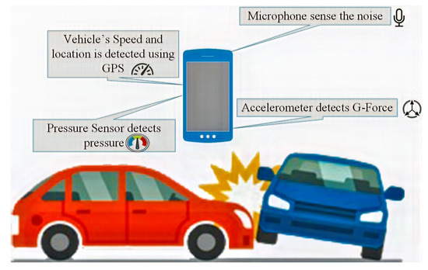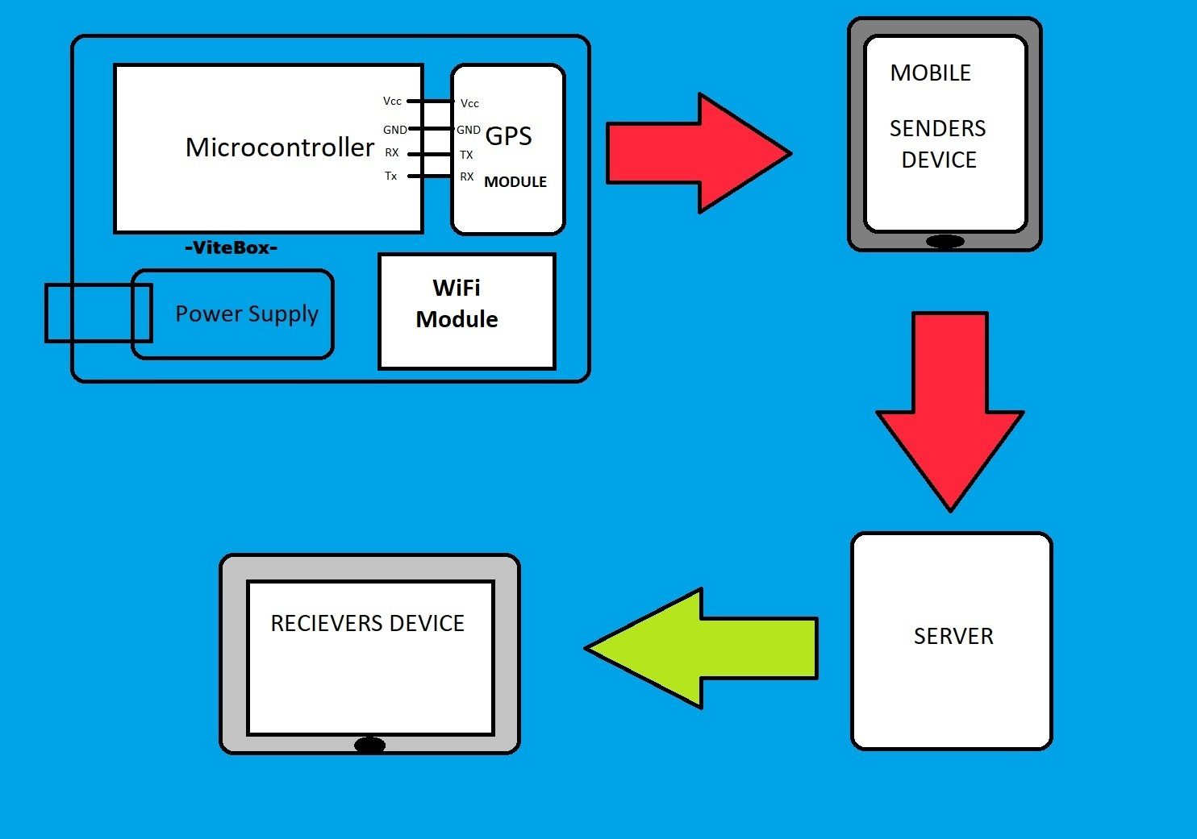

|  |  |  |  |  |  |  |  |  |
| --- | --- | --- | --- | --- | --- | --- | --- | --- |
| **Work Plan:** | August2023 | September  2023 | October  2023 | November 2023 | December  2023 | January 2024 | February  2024 | March  2024 |
| Literature survey |  |  |  |  |  |  |  |  |
| Importing Hardware components |  |  |  |  |  |  |  |  |
| Analysing the sensors required |  |  |  |  |  |  |  |  |
| Compatibility testing |  |  |  |  |  |  |  |  |
| Resolving the errors |  |  |  |  |  |  |  |  |
| Expected output |  |  |  |  |  |  |  |  |

NOTE:

Time Period required to provide expected output is 7 Months. If possible include work plan.

**Budget: The project for above designed plan can be implemented within the range of Rs. 11,310/- only.**

**(Price which is listed in the E-Commerce site.)**

|  |  |  |
| --- | --- | --- |
| **Sl.no** | **Component** | **Amount(Rs.)** |
| **1.** | GPS | 1700 |
| **2.** | MICROCONTROLLER | 1300 |
| **3.** | PEIZO Vibration Sensor | 1800 |
| **4.** | Carbon Fiber Case | 3200 |
| **5.** | Battery | 1900 |
| **6.** | Led | 10 |
| **7.** | Switch | 900 |
| **8.** | Wires | 500 |
|  | TOTAL | 11,310 |

**OUTCOMES:**

A Vehicle Crash Alert System (VCAS) offers numerous benefits for road safety and emergency response:

1. Reduced Accident Severity: VCAS swiftly detects accidents, enabling faster emergency response, potentially reducing injuries and fatalities.

2. Improved Response Times: Automatic alerts to emergency services shorten response times for quicker medical aid and accident clearance.

3. Minimized Secondary Accidents: V2V communication alerts nearby drivers to slow down or change lanes, preventing secondary accidents.

4. Enhanced Post-Accident Investigations: VCAS provides detailed crash data for more accurate post-accident investigations.

5. Increased Road Safety Awareness: VCAS raises driver awareness, encouraging cautious driving.

6. Reduced Traffic Congestion: Faster accident response and clearance reduce traffic congestion.

7. Integration with Autonomous Vehicles: VCAS enhances autonomous vehicle safety.

8. Research and Policy Data: VCAS data aids research and informs road safety policy.

9. Consumer Confidence: VCAS availability boosts consumer confidence in vehicle safety.

10. Emergency Services Efficiency: VCAS streamlines communication with emergency services.

11. Insurance Benefits: Some insurers offer incentives for VCAS-equipped vehicles.

12. Global Road Safety: Widespread VCAS adoption can improve global road safety.